H.T No
Regulations:
A18

Sreenidhi Institute of Science and Technology
(An Autonomous Institution)
Code No: 7A304 Date: 05-Aug-2023 (FN)

B.Tech II-Year I- Semester External Examination, Aug - 2023 (Supplementary)
ELECTRICAL CIRCUITS AND NETWORKS – II (EEE)

Time: 3 Hours Max.Marks:70

Note: a) No additional answer sheets will be provided.
b) All sub-parts of a question must be answered at one place only, otherwise it will not be valued.
c) Missing data can be assumed suitably.

Bloom's Cognitive Levels of Learning (BCLL)

Remember | L1 | Apply | L3 | Evaluate | L5
Understand | L2 | Analyze | L4 | Create | L6

Part - A Max.Marks:20
Answer all QUESTIONS

 |  | BCLL | CO(s) | Marks
1 | Define symmetrical system and phase sequence | L1 | CO1 | [2M]
2 | Explain initial conditions of Capacitor? | L2 | CO2 | [2M]
3 | Define poles and zeros of a system function? | L1 | CO3 | [2M]
4 | Classify different types of two port network parameters? | L3 | CO4 | [2M]
5 | Write short notes on band pass filters? | L1 | CO5 | [2M]
6 | Write the formulae for Fourier constants for f ( x) in the interval (-Π, Π). | L1 | CO6 | [2M]
7 | What is meant by balanced three phase supply? | L1 | CO1 | [2M]
8 | Define DC gain of a system function? | L1 | CO3 | [2M]
9 | What are desirable characteristics of ideal filter? | L1 | CO5 | [2M]
10 | Explain condition of symmetry for z-parameters? | L6 | CO6 | [2M]
Part – B Max.Marks:50
ANSWER ANY FIVE QUESTIONS. EACH QUESTION CARRIES 10 MARKS.

 |  |  | BCLL | CO(s) | Marks
11. | a) | Derive the relationship between a line current and phase current and a line voltage and a phase voltage related to delta connected load. | L5 | CO1 | [5M]
 | b) | Two watt meters connected to measure the input to a balanced 3-ϕ circuit indicate 2000W and 500W respectively. Find the power factor of the circuit:  - When both readings are positive  - When the latter is obtained after reversing the connection to the current coil of one instrument. | L3 | CO1 | [5M]
12. | a) | Derive the expression for transient response of series R-C circuit driven by sinusoidal excitation by using Laplace transform method. | L5 | CO2 | [5M]
 | b) | A series RC circuit has a constant voltage of E, applied at time t = 0 as shown in Fig. below. The capacitor has no initial charge. Find the equations for i, V_{R} and V_{C}. Sketch the wave shapes. E = 100 V R = 5000Ω C = 20 μF  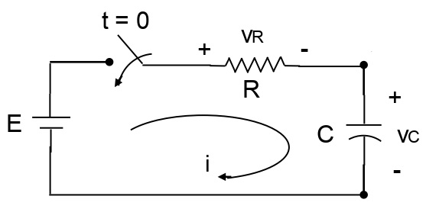 | L3 | CO2 | [5M]
13. | a) | Compute the driving point impedance Z(s) of the network shown in below figure. Locate poles and zeros of Z(s) on s-plane  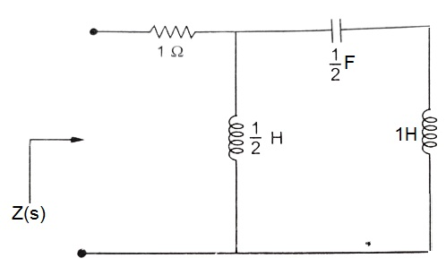 | L2 | CO3 | [5M]
 | b) | Write the necessary conditions for driving point and transfer function. | L1 | CO3 | [5M]
14. | a) | Obtain the z parameters for the network in Fig.  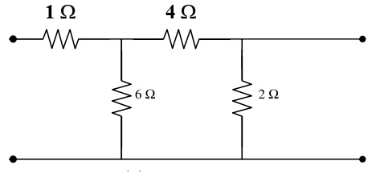 | L3 | CO4 | [5M]
 | b) | Discuss the condition of Reciprocity in h-Parameter representation. | L2 | CO4 | [5M]
15. | a) | Write short notes on band pass and RC filters. | L1 | CO5 | [5M]
 | b) | Explain in detail about constant m-derived filters. | L2 | CO5 | [5M]
16. | a) | Write note on i) Half wave symmetry ii) Quarter wave symmetry | L1 | CO6 | [5M]
 | b) | What are the fourier coefficients? Derive the expressions for the fourier coefficients of the fourier series. | L5 | CO6 | [5M]
17. | a) | Explain critically damped response of series RLC circuit for DC excitation. | L2 | CO1 | [4M]
 | b) | State the power relations for a 3-ϕ system and explain a power triangle. | L1 | CO2 | [3M]
 | c) | For the given one port network shown in below figure. Find driving point impedance function Z(s)  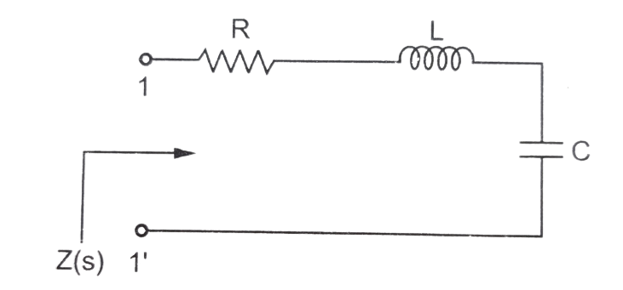 | L3 | CO3 | [3M]
18. | a) | Express ABCD parameters in terms of h parameters. | L5 | CO4 | [4M]
 | b) | A prototype high pass filter has a cut off frequency of 8 KHz and nominal impedance of 600 ohms. Calculate the values of inductance and capacitance used in the filter. | L3 | CO5 | [3M]
 | c) | Find the fourier transform of the time function 3e^{-t} cos4t u(t) | L3 | CO6 | [3M]

-- 00 -- 00 –

